Terraform Task -06

Overall Task Title
Provision AWS Infrastructure Using Terraform Modules and Workspaces
Objective
The objective of this task is to understand and implement Infrastructure as Code using Terraform by executing the provided Terraform script to provision AWS resources. This includes creating a VPC, EC2 instance, and S3 bucket using reusable Terraform modules, and deploying environment-specific EC2 instances (Dev, Staging, and Prod) using Terraform workspaces to ensure isolated state management and environment-based configuration.
Prerequisites
- Basic understanding of Terraform concepts and workflow
- AWS account with sufficient permissions to create:
  - VPC
  - EC2 instances
  - S3 buckets
  - Security Groups
- AWS CLI installed and configured (aws configure)
- Terraform installed (version 1.3.0 or higher)
- Access to the Terraform-06 training video
- Stable internet connection to download Terraform modules
- Code editor (VS Code recommended)
- Default VPC or permission to create new VPCs in AWS

1. Execute the script shown in the video.
Task Title
Provisioning AWS EC2 Instance Using Terraform with Modules, Variables, and Workspaces
Objective
To create and manage AWS EC2 instances using Terraform by:
- Launching EC2 instances successfully
- Fixing AMI-related errors
- Modularizing Terraform code
- Using variables and workspaces
- Managing Development environment separately
Prerequisites
- AWS account with valid credentials
- AWS CLI configured (aws configure)
- Terraform installed
- Internet connectivity to access AWS STS and Terraform Registry
- Valid EC2 Key Pair
- Basic understanding of Terraform structure

Steps Performed
Step 1: Created Basic EC2 Instance Using Terraform
- Created aws_instance resource in Main.tf
- Specified:
  - AMI ID
  - Instance type (t3.micro)
- Ran:
- terraform init
- terraform apply
- EC2 instance creation started but initially failed due to AMI issues
Step 2: Resolved AMI Errors
- Encountered repeated error:
- InvalidAMIID.Malformed
- Updated AMI ID to a valid Amazon Linux AMI
- Re-ran:
- terraform init
- terraform apply
- EC2 instance created successfully
- Verified instance in AWS EC2 Console (Running state)
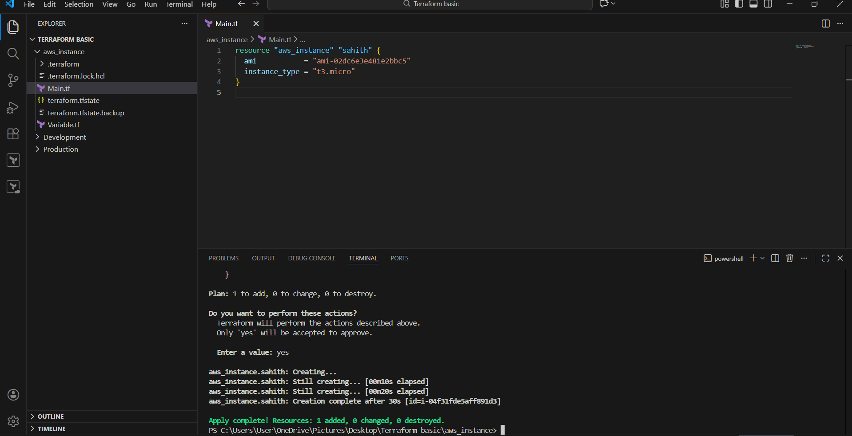
Step 3: Verified EC2 Instance in AWS Console
- Navigated to EC2 → Instances
- Confirmed:
  - Instance state: Running
  - Instance type: t3.micro
  - Public IP assigned
- This confirmed Terraform provisioning worked correctly
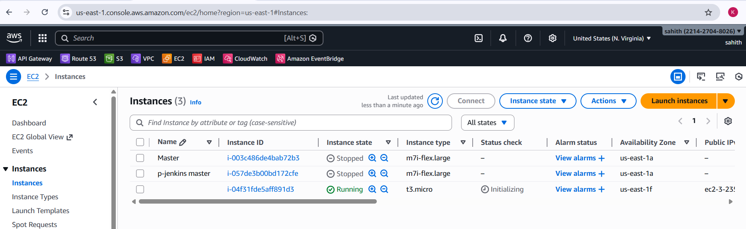
Step 4: Introduced Variables for AMI
- Created Variable.tf
- Defined AMI as a variable:
- variable "ami" {}
- Updated Main.tf to use:
- ami = var.ami
- This improved reusability and configurability
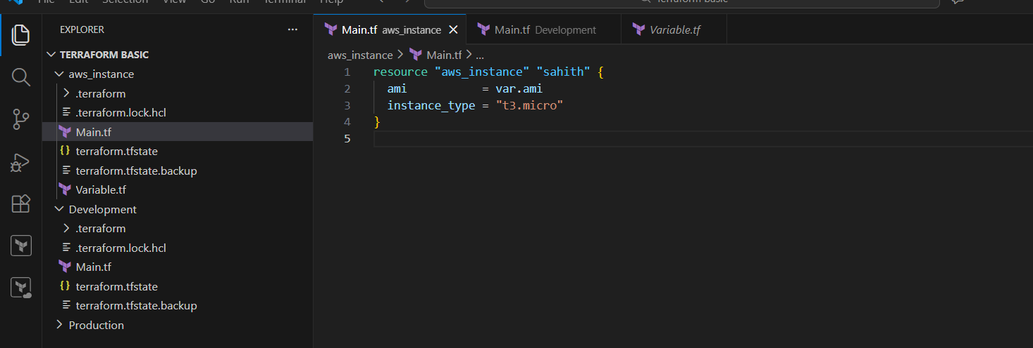
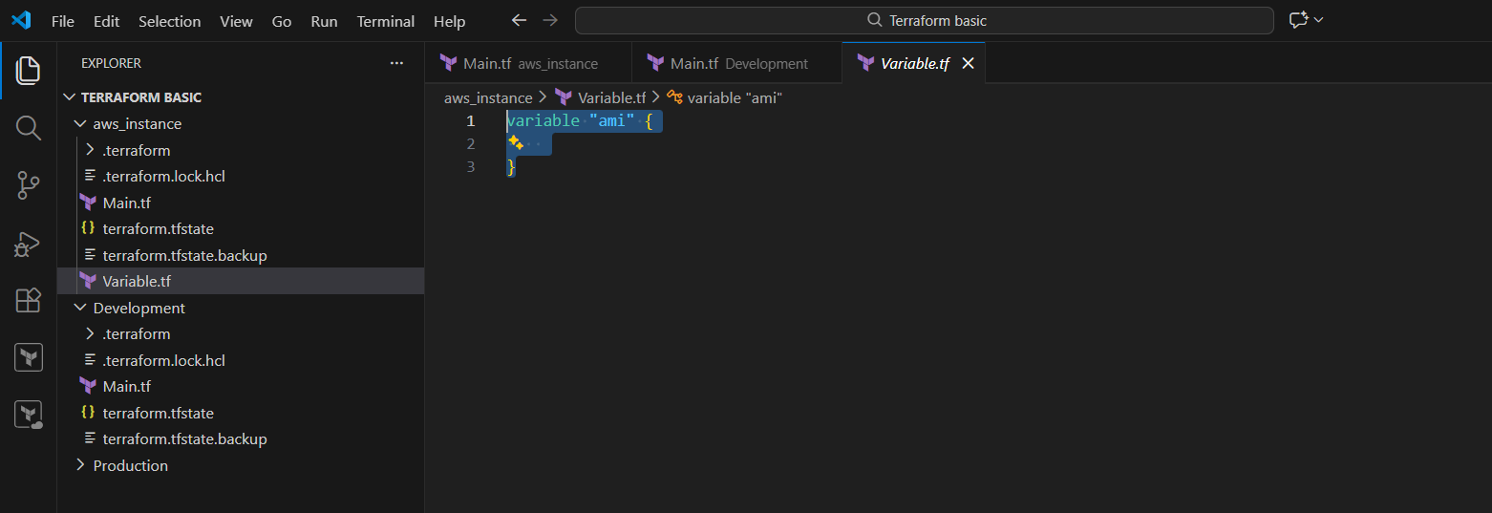
Step 5: Created Development Environment Using Terraform Modules
- Created folder structure:
- Terraform basic/
- ── aws_instance
- ── Development
- ── Production
- In Development/Main.tf, called module:
- module "dev-sahith" {
- source = "../aws_instance"
- ami = "ami-02dc6e3e481e2bbc5"
- }
- Ran:
- terraform init
- terraform apply
- Fixed errors related to:
  - Unsupported arguments
  - Missing variables
  - Provider configuration
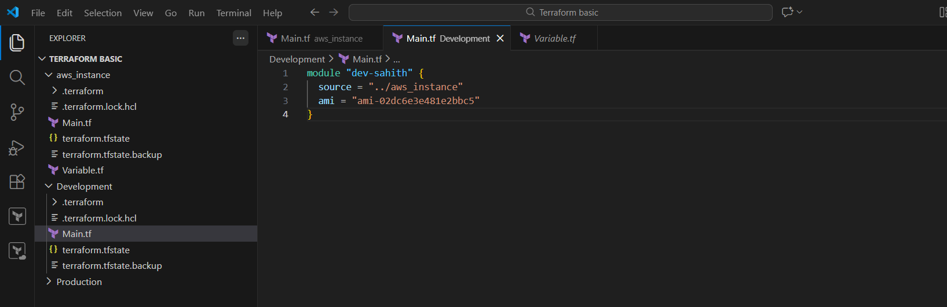
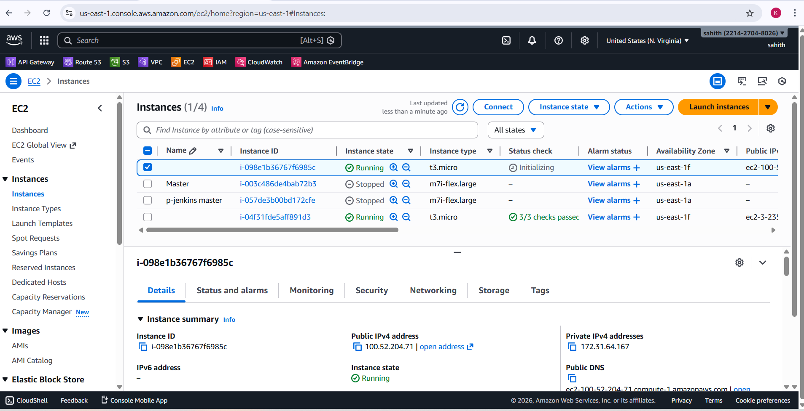
Step 6: Implemented Terraform Workspaces
- Created and switched workspace:
- terraform workspace new Dev
- terraform workspace list
- Used workspace-specific state isolation
- Verified new state file:
- terraform.tfstate.d/Dev
- Applied changes successfully in Dev workspace
Step 7: Used Map Variable for Multiple AMIs
- Updated Variable.tf:
- variable "ami" {
- type = map(string)
- default = {
- ProjectA = "ami-07ff6235b87c7116"
- ProjectB = "ami-07ff6235b87c7116"
- }
- }
- Updated resource:
- ami = var.ami["ProjectA"]
- Terraform destroyed old instance and created a new one as expected
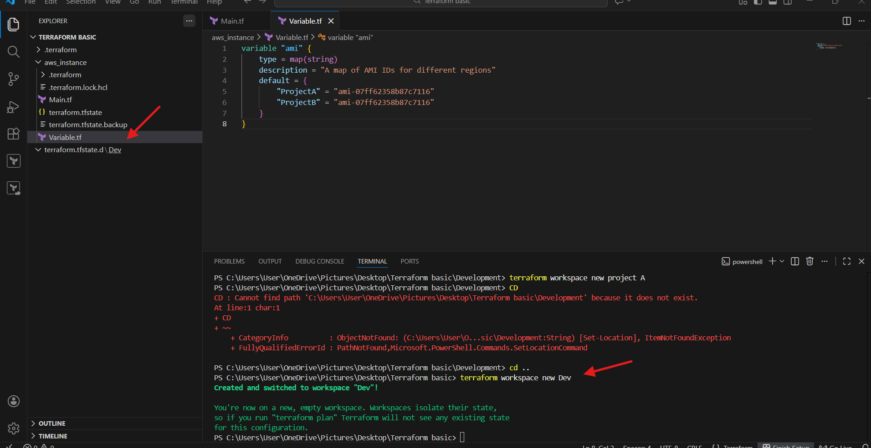
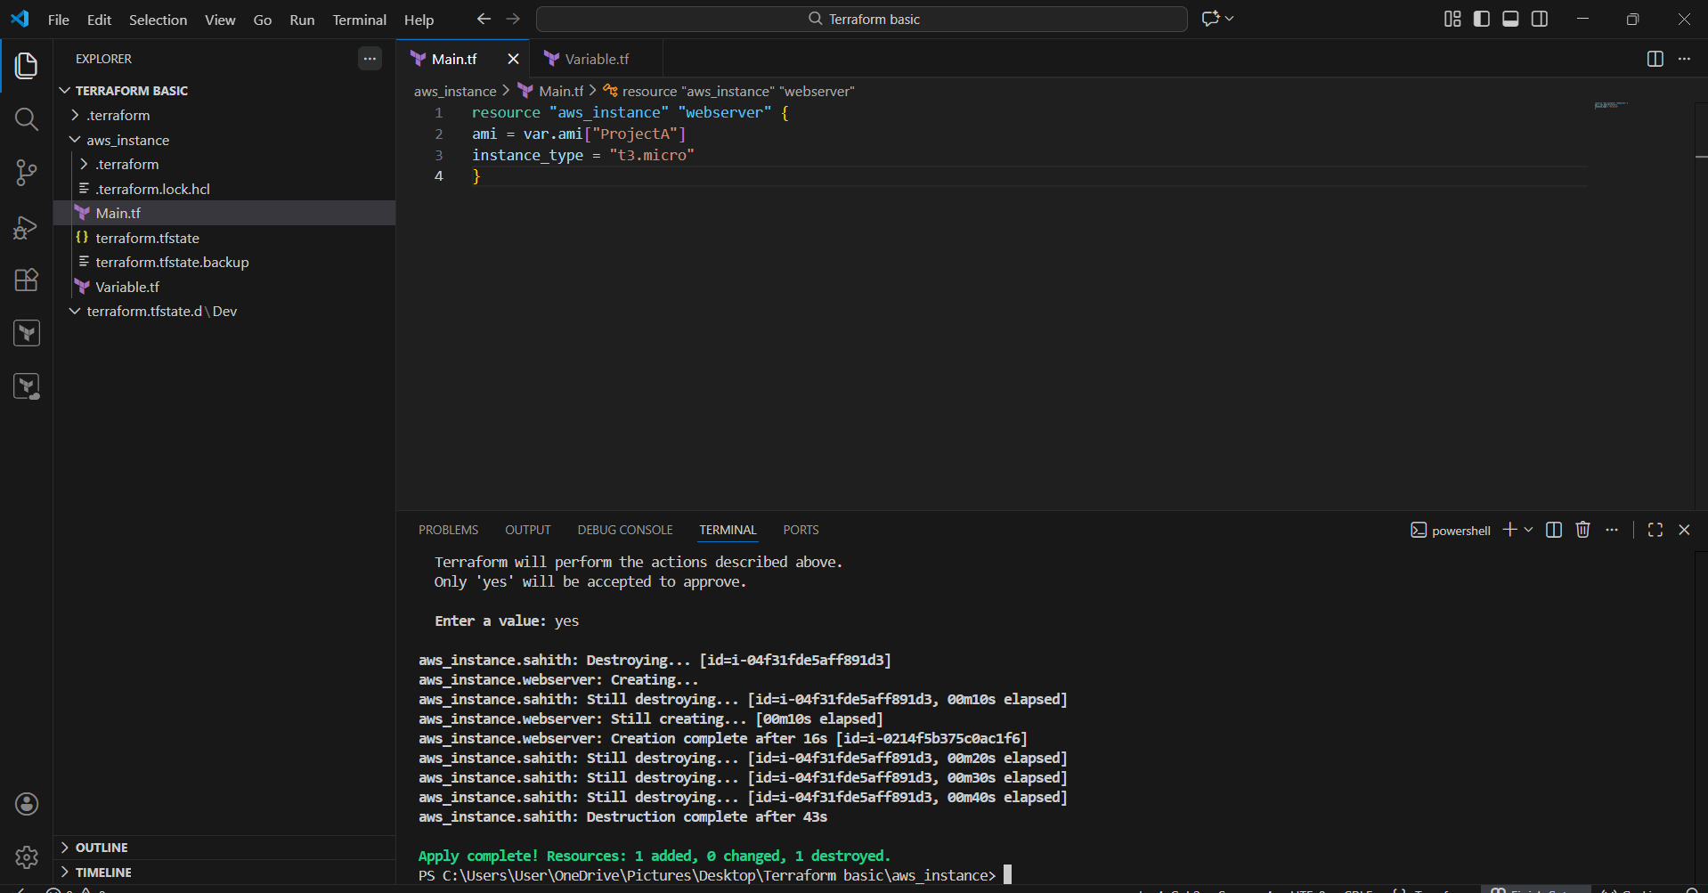
Step 8: Verified Resource Lifecycle Changes
- Terraform output showed:
- 1 added, 0 changed, 1 destroyed
- Verified new EC2 instance in AWS Console
- Confirmed old instance termination and new instance creation
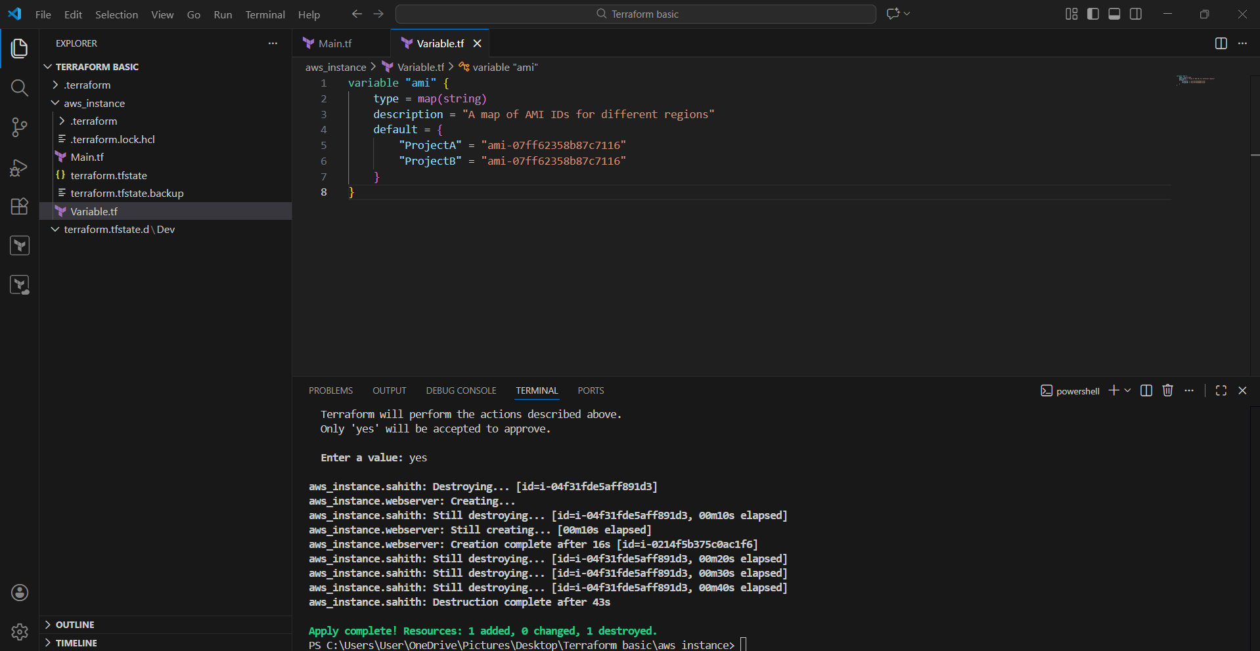
Issues Faced
- Invalid AMI ID errors
- Unsupported module arguments
- Missing provider configuration
- Network/DNS connectivity issues to AWS STS
- Incorrect folder navigation paths
Conclusion
Successfully provisioned AWS EC2 instances using Terraform by:
- Fixing AMI and provider issues
- Using variables for flexibility
- Implementing Terraform modules
- Managing environments with workspaces
- Validating infrastructure through AWS Console
This task demonstrates end-to-end Terraform infrastructure provisioning with real-world troubleshooting.

Task Title
Provision AWS VPC, EC2 Instance, and S3 Bucket Using Terraform Modules
Objective
The objective of this task is to provision a complete AWS infrastructure using Terraform modules. This includes creating a custom Virtual Private Cloud (VPC) with public and private subnets, deploying an EC2 instance in a public subnet, and creating an S3 bucket with a unique name. The task also demonstrates modular, reusable, and version-controlled Infrastructure as Code (IaC) practices.
Prerequisites
- AWS account with appropriate IAM permissions
- Terraform installed (version >= 1.3.0)
- AWS CLI configured with valid credentials
- Basic understanding of AWS networking concepts (VPC, subnets, gateways)
- Internet access to download Terraform providers and modules
Step-by-Step Implementation:
Step 1: Terraform and AWS Provider Configuration
- Defined the required Terraform version and AWS provider version (~> 5.83).
- Configured the AWS provider to use the us-east-1 region.
- This ensures consistent provider behaviour across environments.
Step 2: VPC Creation Using Terraform Module
- Used the official Terraform AWS VPC module (terraform-aws-modules/vpc/aws).
- Created a VPC named task-vpc with CIDR block 10.0.0.0/22.
- Configured three Availability Zones for high availability.
- Created:
  - Three public subnets
  - Three private subnets
- Enabled:
  - Internet Gateway for public access
  - NAT Gateway for outbound internet access from private subnets
- Disabled VPN gateway as it was not required.
- Applied environment and Terraform tags for resource tracking.
Step 3: EC2 Instance Deployment Using Terraform Module
- Used the Terraform EC2 instance module (terraform-aws-modules/ec2-instance/aws).
- Created an EC2 instance named task-ec2.
- Instance configuration:
  - Instance type: t3.micro
  - AMI ID: ami-02dc6e3e481e2bbc5
  - Deployed in the first public subnet
  - Public IPv4 address enabled
- Tags were applied for environment identification.
Step 4: S3 Bucket Creation Using Terraform Module
- Used the Terraform S3 bucket module (terraform-aws-modules/s3-bucket/aws).
- Bucket name generated dynamically using a random suffix to avoid global naming conflicts:
- terratask-<random_id>
- Enabled force_destroy to allow bucket deletion even if objects exist.
- Applied Terraform and environment tags.
Step 5: Random ID Resource for Unique Bucket Naming
- Created a random_id resource with a byte length of 4.
- Ensured uniqueness of the S3 bucket name across AWS.
- Prevented bucket creation failures due to name collisions.
Step 6: Terraform Outputs
- Defined output values to display important infrastructure details:
  - VPC ID
  - EC2 public IP address
  - S3 bucket name
- Outputs confirm successful resource provisioning.
Terraform code:
terraform {
required_version = ">= 1.3.0"

required_providers {
aws = {
source = "hashicorp/aws"
version = "~> 5.83"
}
}
}

provider "aws" {
region = "us-east-1"
}

# ----------------------------
# VPC MODULE
# ----------------------------
module "vpc" {
source = "terraform-aws-modules/vpc/aws"
version = "5.21.0"

name = "task-vpc"
cidr = "10.0.0.0/22"

azs = ["us-east-1a", "us-east-1b", "us-east-1c"]

private_subnets = [
"10.0.0.0/26",
"10.0.0.64/26",
"10.0.0.128/26"
]

public_subnets = [
"10.0.1.0/26",
"10.0.1.64/26",
"10.0.1.128/26"
]

enable_nat_gateway = true
single_nat_gateway = true
enable_vpn_gateway = false

tags = {
terraform = "true"
environment = "dev"
}
}

# ----------------------------
# EC2 MODULE
# ----------------------------
module "ec2" {
source = "terraform-aws-modules/ec2-instance/aws"
version = "5.8.0"

name = "task-ec2"

ami = "ami-02dc6e3e481e2bbc5"
instance_type = "t3.micro"

subnet_id = module.vpc.public_subnets[0]
associate_public_ip_address = true

tags = {
terraform = "true"
environment = "dev"
}
}

# ----------------------------
# S3 MODULE
# ----------------------------
module "s3" {
source = "terraform-aws-modules/s3-bucket/aws"
version = "4.11.0"

bucket = "terratask-${random_id.bucket_task06sa.hex}"

force_destroy = true

tags = {
terraform = "true"
environment = "dev"
}
}

# Random suffix to avoid bucket name conflicts
resource "random_id" "bucket_task06sa" {
byte_length = 4
}

# ----------------------------
# OUTPUTS
# ----------------------------
output "vpc_id" {
value = module.vpc.vpc_id
}

output "ec2_public_ip" {
value = module.ec2.public_ip
}

output "s3_bucket_name" {
value = module.s3.s3_bucket_id
}
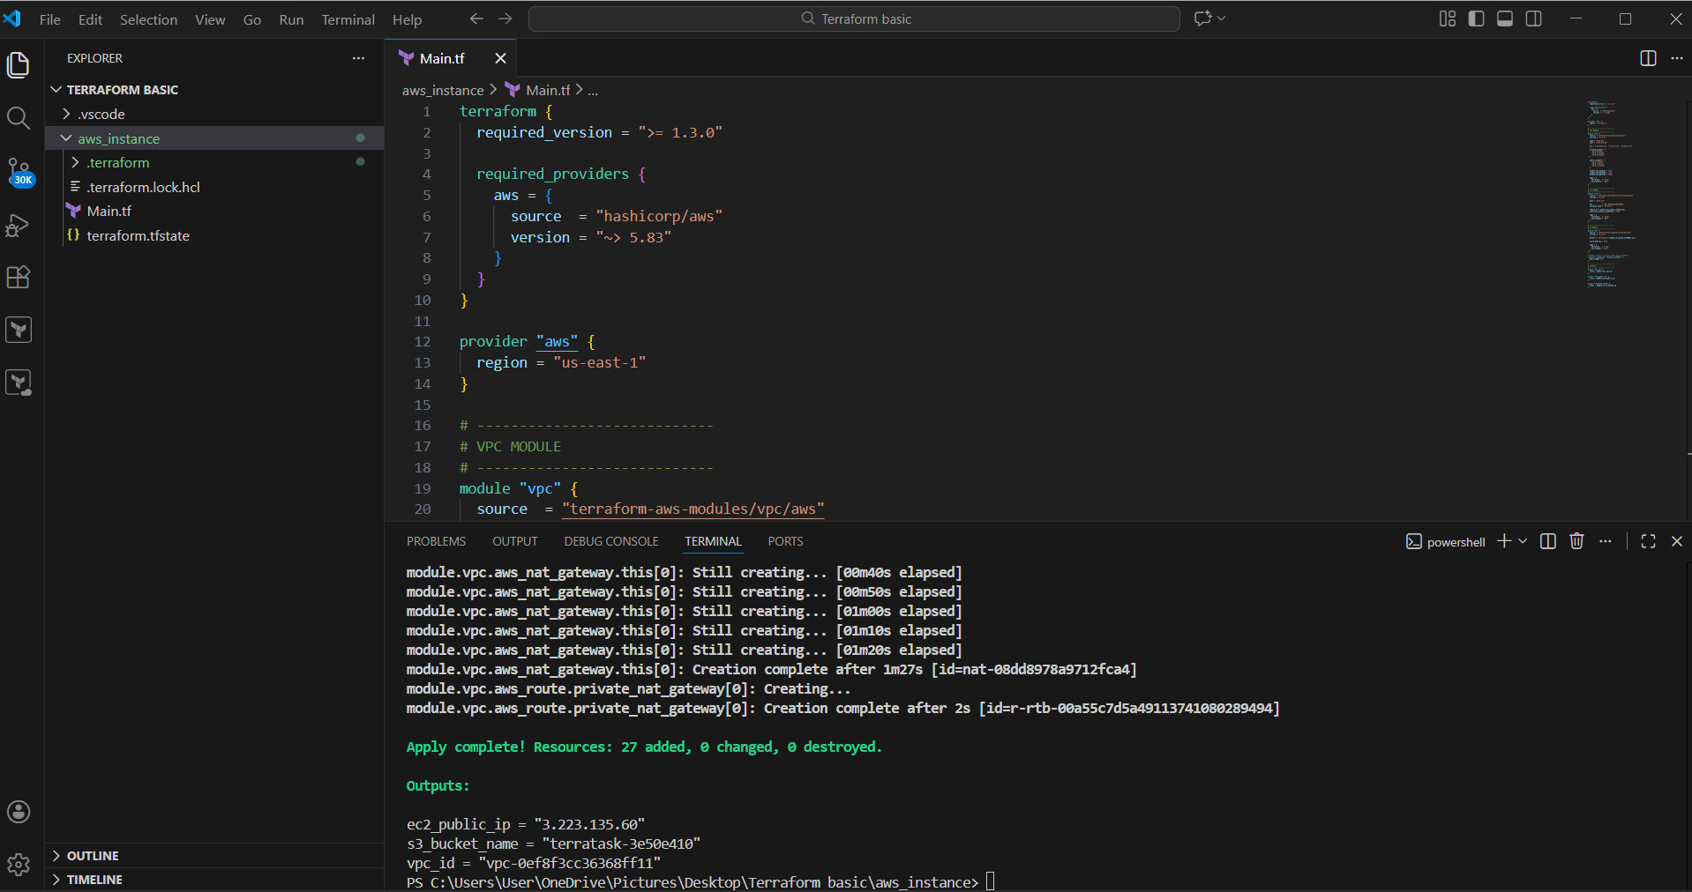
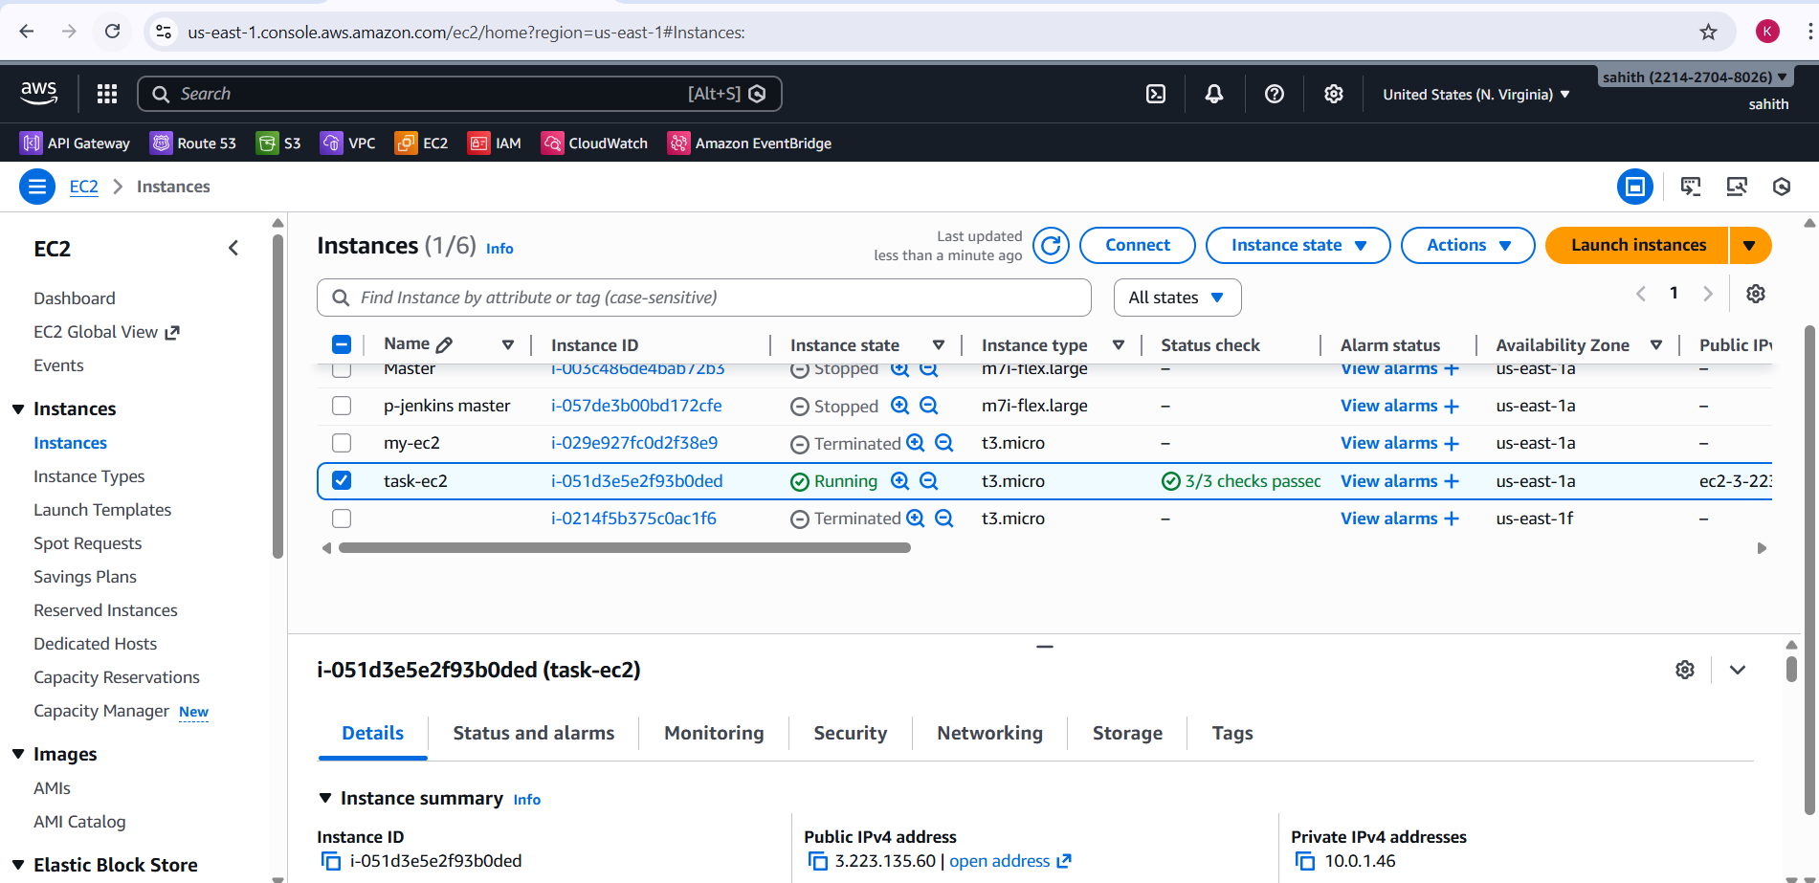
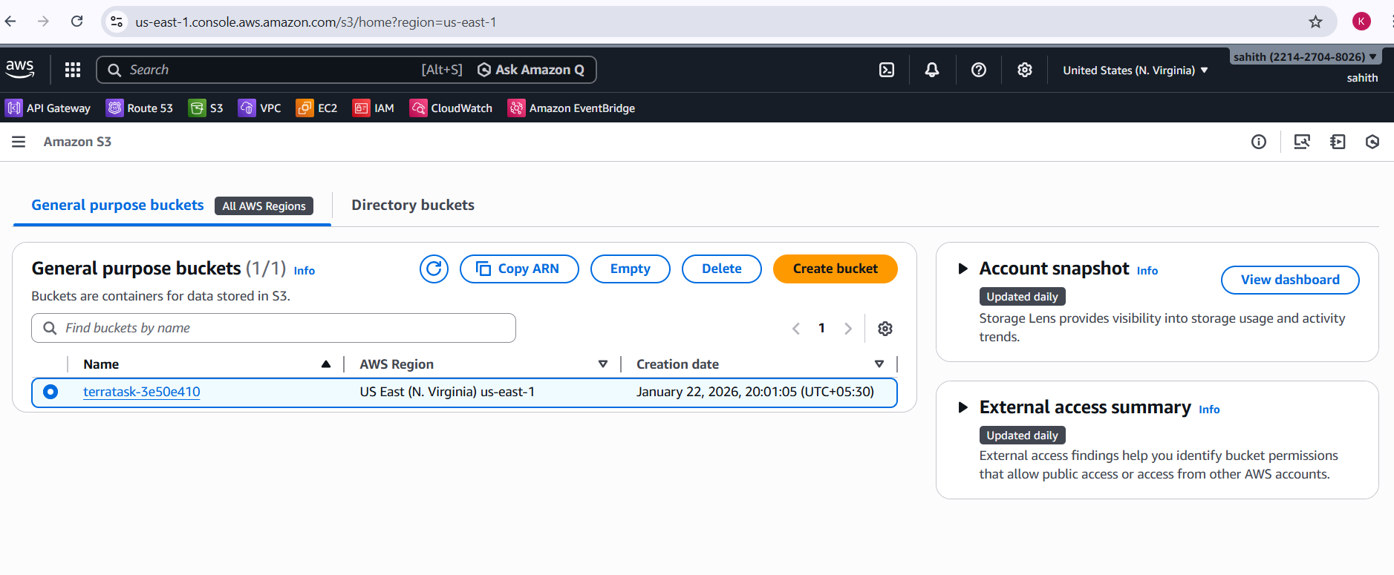
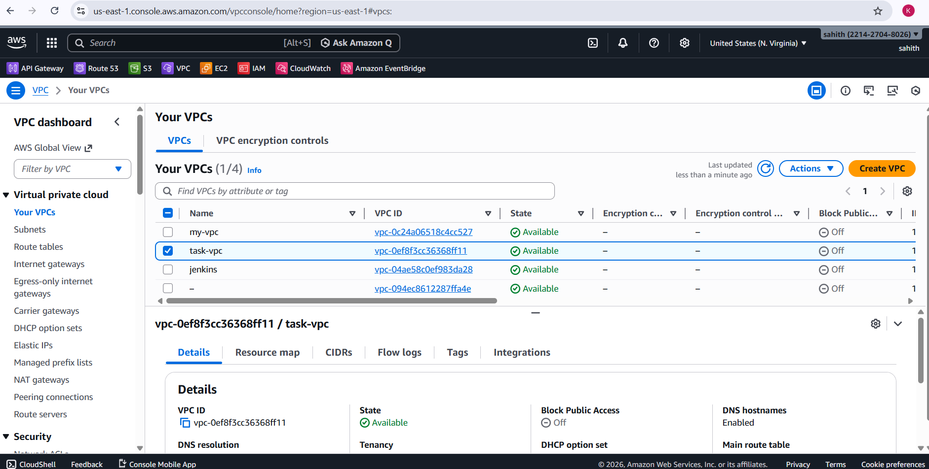
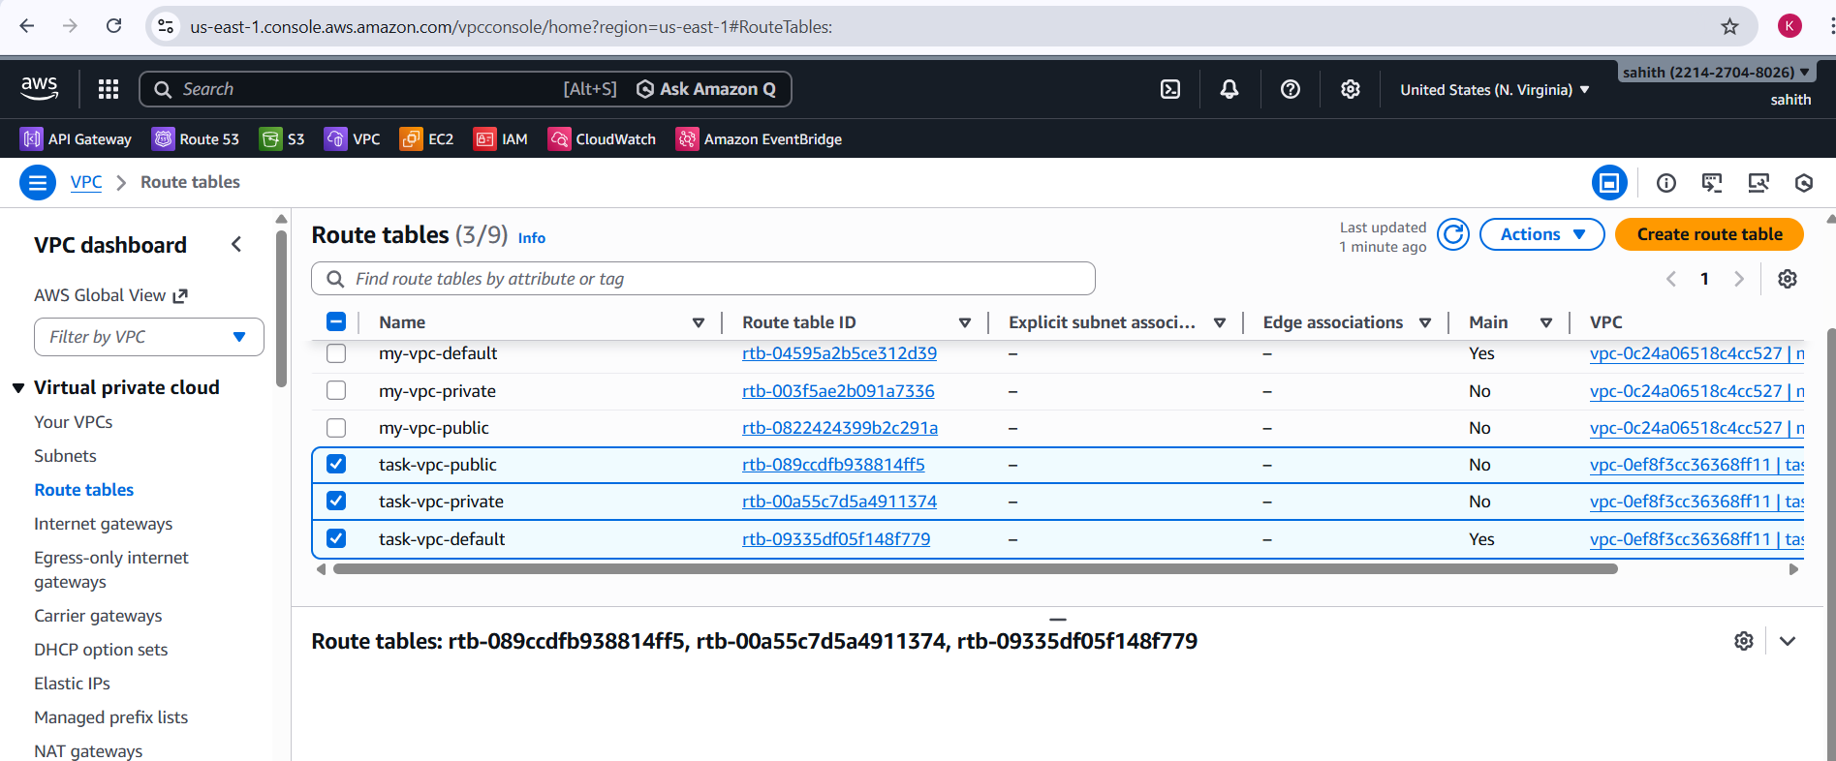
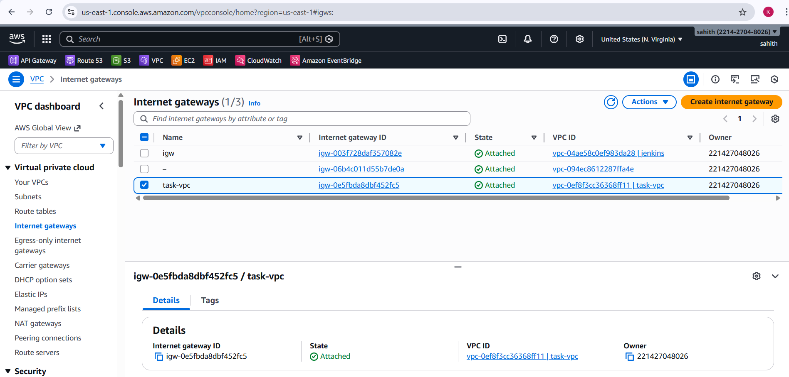
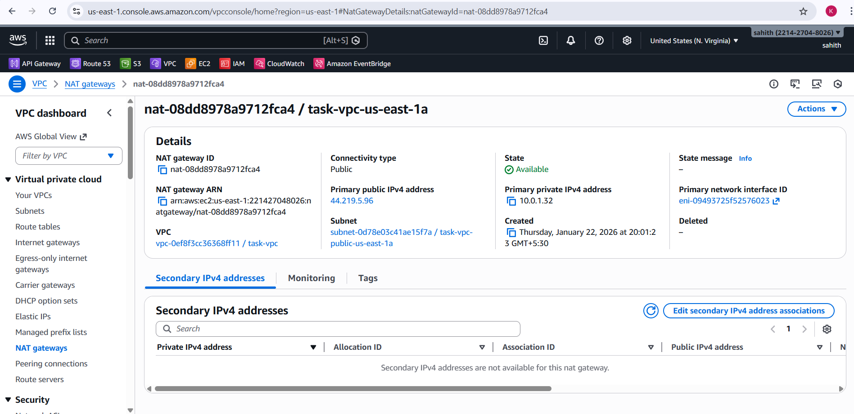
Validation Steps
- Verified VPC, subnets, route tables, Internet Gateway, and NAT Gateway in AWS VPC console.
- Confirmed EC2 instance task-ec2 was in Running state with a public IP.
- Verified S3 bucket creation in the Amazon S3 console.
- Checked Terraform output values after successful terraform apply.
Issues Faced
- Initial provider and module version mismatches caused unsupported argument errors.
- Resolved by aligning AWS provider and module versions.
- S3 bucket name conflicts were resolved using a random ID suffix.
Conclusion
This task successfully demonstrated how to use Terraform modules to provision a scalable AWS infrastructure. A custom VPC with secure networking, a publicly accessible EC2 instance, and a uniquely named S3 bucket were deployed using best practices. The implementation highlights modular design, version control, and automation using Infrastructure as Code, ensuring repeatability and maintainability.

Task Title
Provision Environment-Specific EC2 Instances Using Terraform Workspaces (dev, staging, prod)
Objective
To provision EC2 instances in AWS using Terraform workspaces so that different environments (dev, staging, prod) automatically deploy:
- Different instance types
- Different instance names
- Isolated Terraform state per environment
- Resources deployed in the default VPC and subnets
Prerequisites
- AWS account with EC2 access
- AWS CLI configured (aws configure)
- Terraform v1.3.0 or later installed
- IAM permissions for:
  - EC2
  - VPC (read)
  - Security Groups
- Default VPC available in the selected AWS region
- PowerShell / Terminal access
- VS Code (optional, for editing and visibility)
Step-by-Step Implementation:
Step 1: Define Terraform and Provider Configuration
- Configured Terraform required version and AWS provider version.
- Selected AWS region.
- Ensured provider compatibility with EC2 resources.
Result: Terraform initialized successfully.
Step 2: Use Terraform Workspaces for Environment Isolation
- Created and switched workspaces:
  - dev
  - staging
  - prod
- Used terraform.workspace to dynamically detect the active environment.
Evidence:
- Terminal shows:
  - Created and switched to workspace "dev"
  - Created and switched to workspace "staging"
  - Created and switched to workspace "prod"
Step 3: Configure Local Maps for Environment-Based Values
- Defined locals for:
  - Instance type per environment
  - Instance name per environment
- Ensured consistent naming and sizing strategy across environments.
Outcome:
- dev → t3.micro
- staging → t3. small
- prod → t3.small
Step 4: Read Default VPC and Subnets
- Used data sources to fetch:
  - Default VPC
  - All subnets associated with the default VPC
- Avoided hardcoding VPC or subnet IDs.
Benefit:
- Configuration remains reusable across accounts and regions.
Step 5: Create Environment-Specific Security Group
- Created a security group dynamically named using the workspace.
- Attached it to the default VPC.
- Tagged resources with environment metadata.
Result:
- Security group created separately for each workspace.
Step 6: Provision EC2 Instance
- Deployed EC2 instance using:
  - Environment-based instance type
  - Environment-based instance name
  - Default subnet
  - Public IP enabled
  - Workspace-specific security group
Evidence:
- Terraform apply completed successfully in:
  - dev workspace → EC2 created
  - staging workspace → EC2 created
  - prod workspace → EC2 created
Step 7: Validate Outputs
- Printed Terraform outputs:
  - Environment name
  - Instance type
  - Public IP address
Observed Outputs:
- environment = dev | staging | prod
- instance_type = t3.micro / t3.small
- public_ip = <assigned IP>
Step 8: Verify in AWS Console
- Confirmed EC2 instances in AWS Console:
  - task-ec2-dev
  - task-ec2-staging
  - task-ec2-prod
- Verified:
  - Correct instance type
  - Correct availability zone
  - Instance state = Running
  - Public IP assigned
Terraform script:
terraform {
required_version = ">= 1.3.0"
required_providers {
aws = {
source = "hashicorp/aws"
version = "~> 5.63"
}
}
}

provider "aws" {
region = "us-east-1"
}
locals {
env = terraform.workspace
instance_type_map = {
dev = "t3.micro"
staging = "t3.small"
prod = "t3.small"
}
instance_name_map = {
dev = "task-ec2-dev"
staging = "task-ec2-staging"
prod = "task-ec2-prod"
}
}
# Default VPC
data "aws_vpc" "default" {
default = true
}
# Default Subnets
data "aws_subnets" "default" {
filter {
name = "vpc-id"
values = [data.aws_vpc.default.id]
}
}
# Security Group
resource "aws_security_group" "sg" {
name = "${local.env}-sg"
description = "Security group for ${local.env} environment"
vpc_id = data.aws_vpc.default.id
tags = {
Name = "${local.env}-sg"
environment = local.env
terraform = "true"
}
}
# EC2 Instance
resource "aws_instance" "app" {
ami = "ami-02dc6e3e481e2bbc5"
instance_type = local.instance_type_map[local.env]
subnet_id = data.aws_subnets.default.ids[0]
vpc_security_group_ids = [aws_security_group.sg.id]
associate_public_ip_address = true

tags = {
Name = local.instance_name_map[local.env]
environment = local.env
terraform = "true"
}
}
output "environment" {
value = local.env
}
output "instance_type" {
value = aws_instance.app.instance_type
}
output "public_ip" {
value = aws_instance.app.public_ip
}
Note: used this script for for all three as default
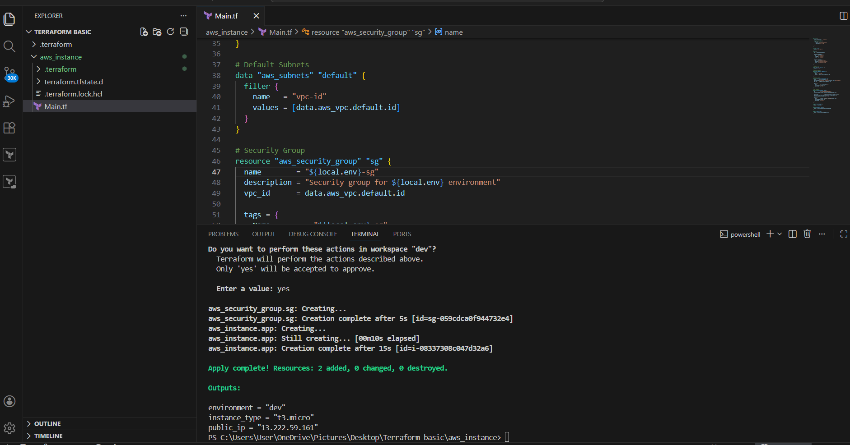
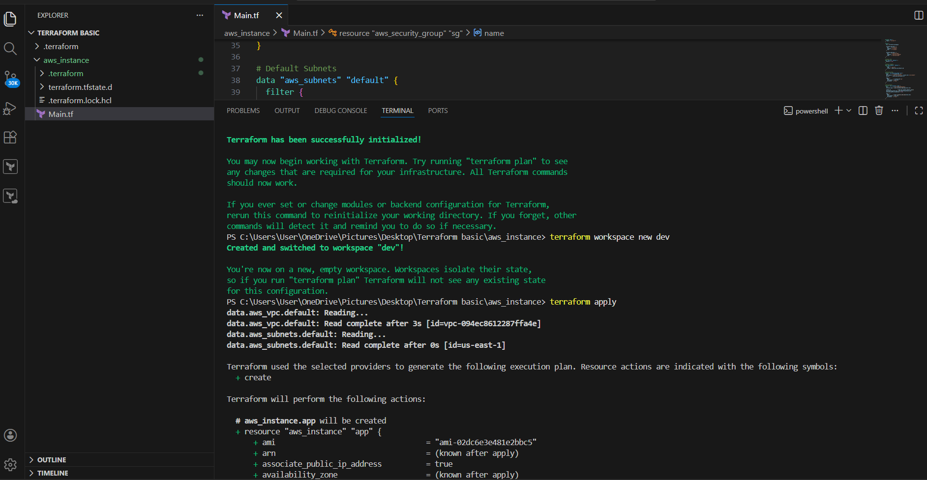
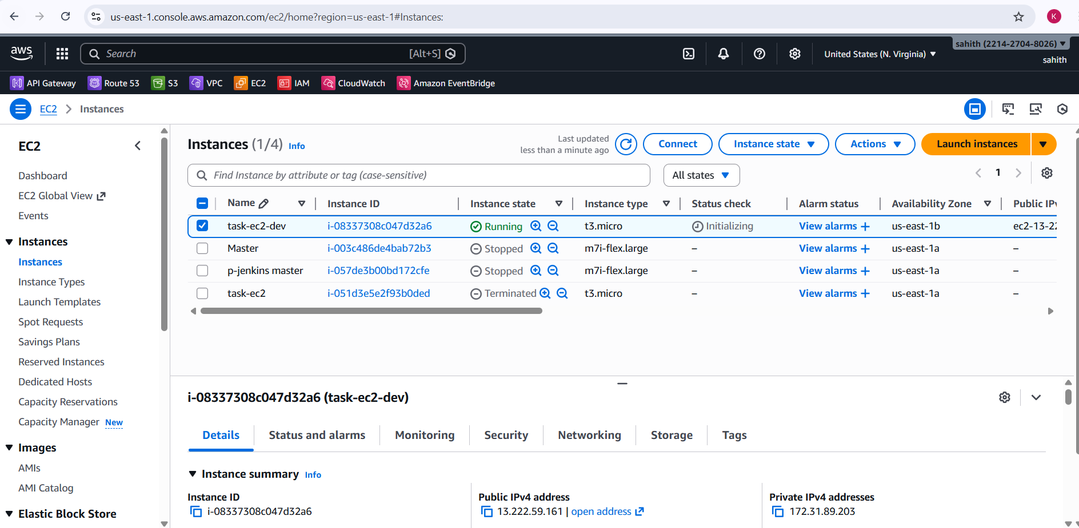
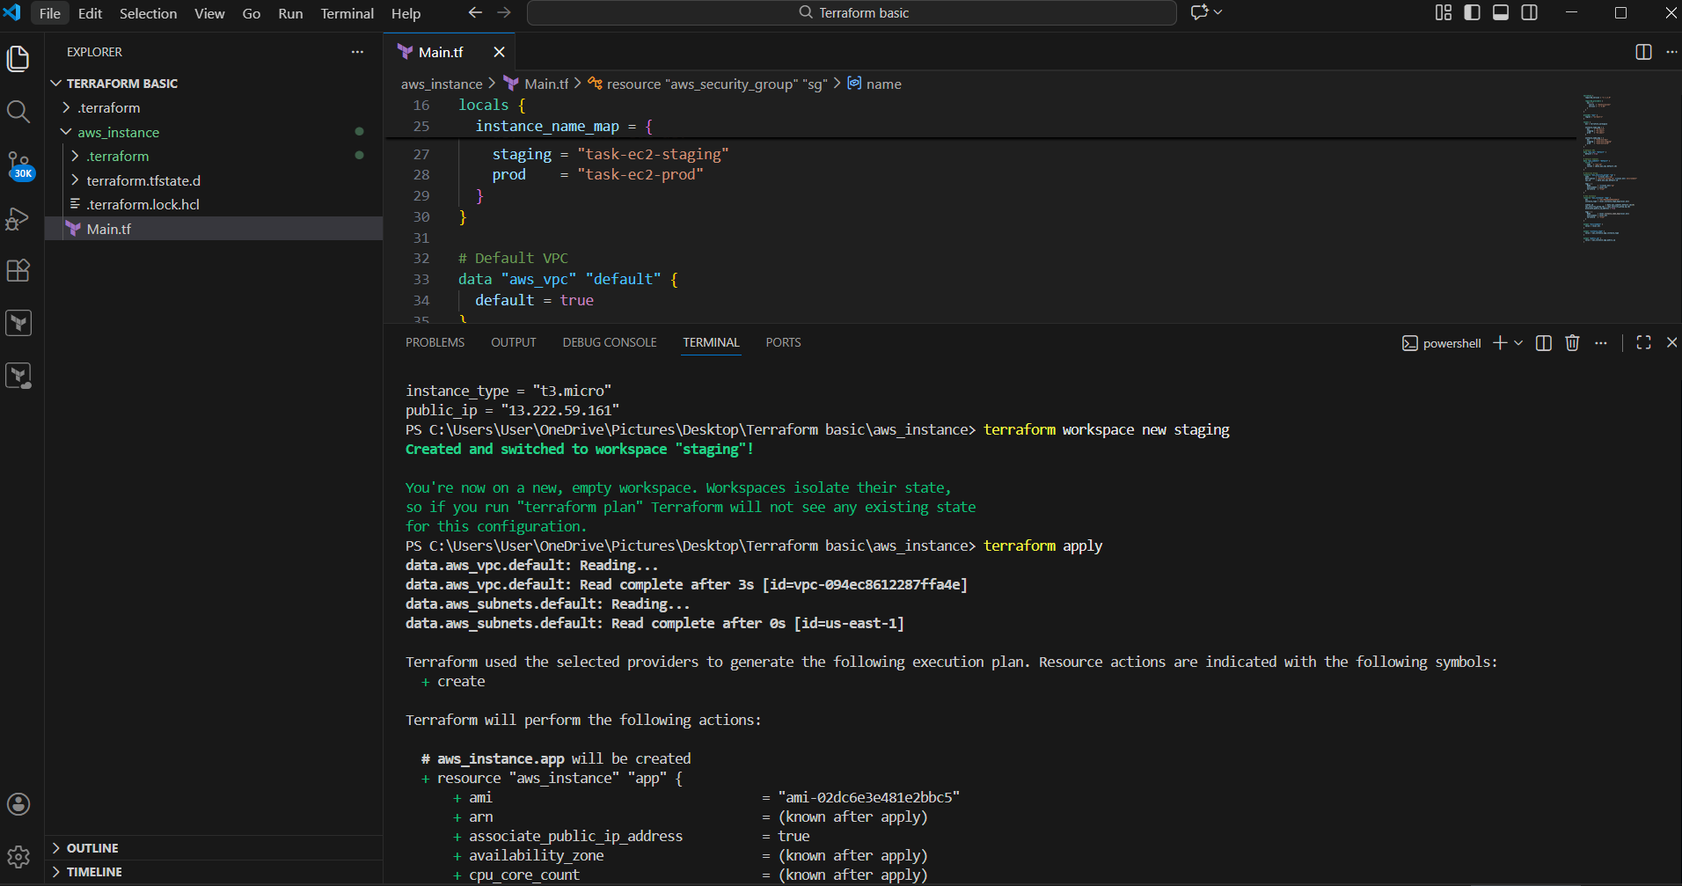
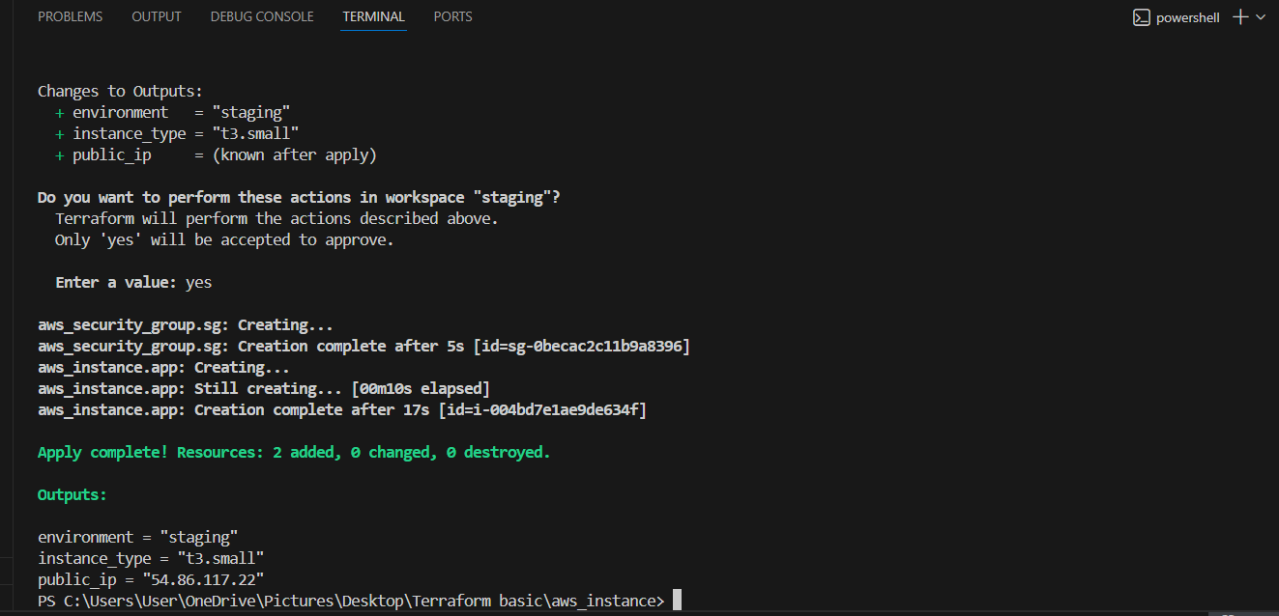
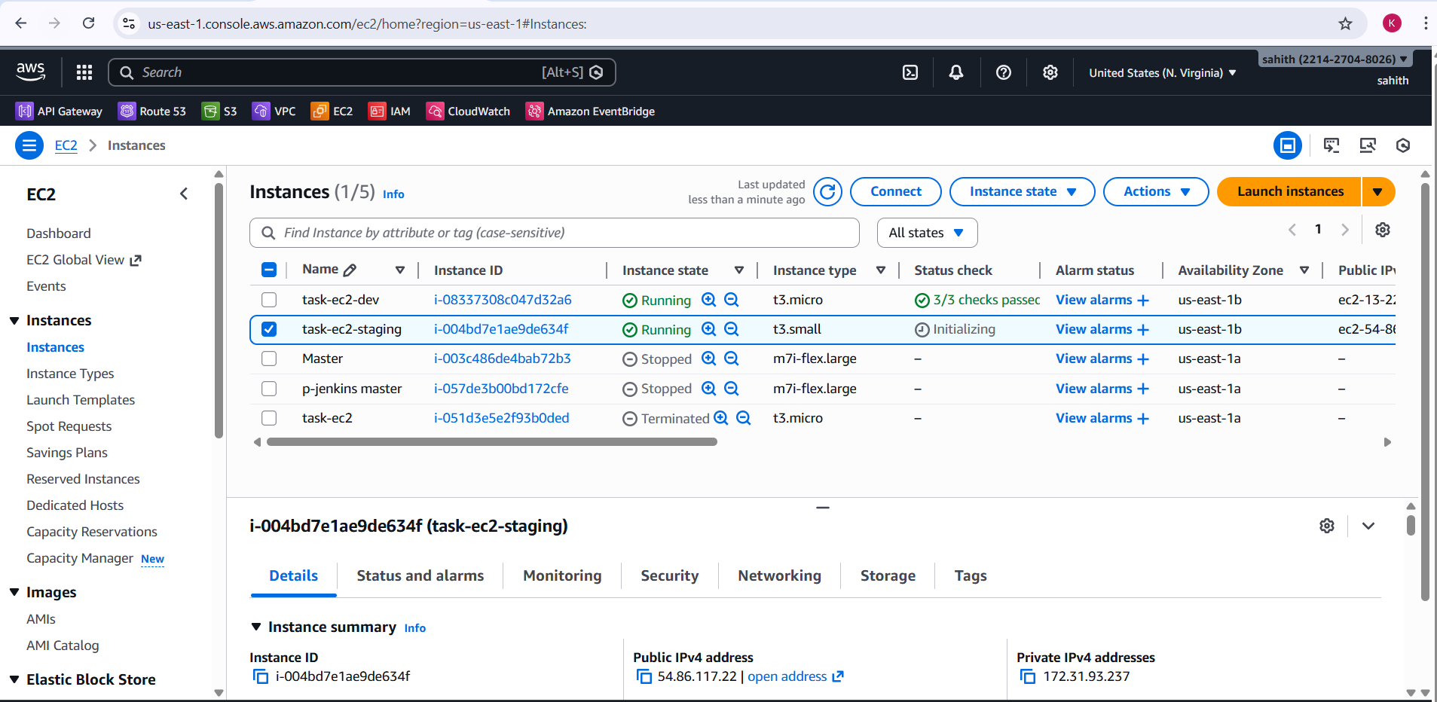
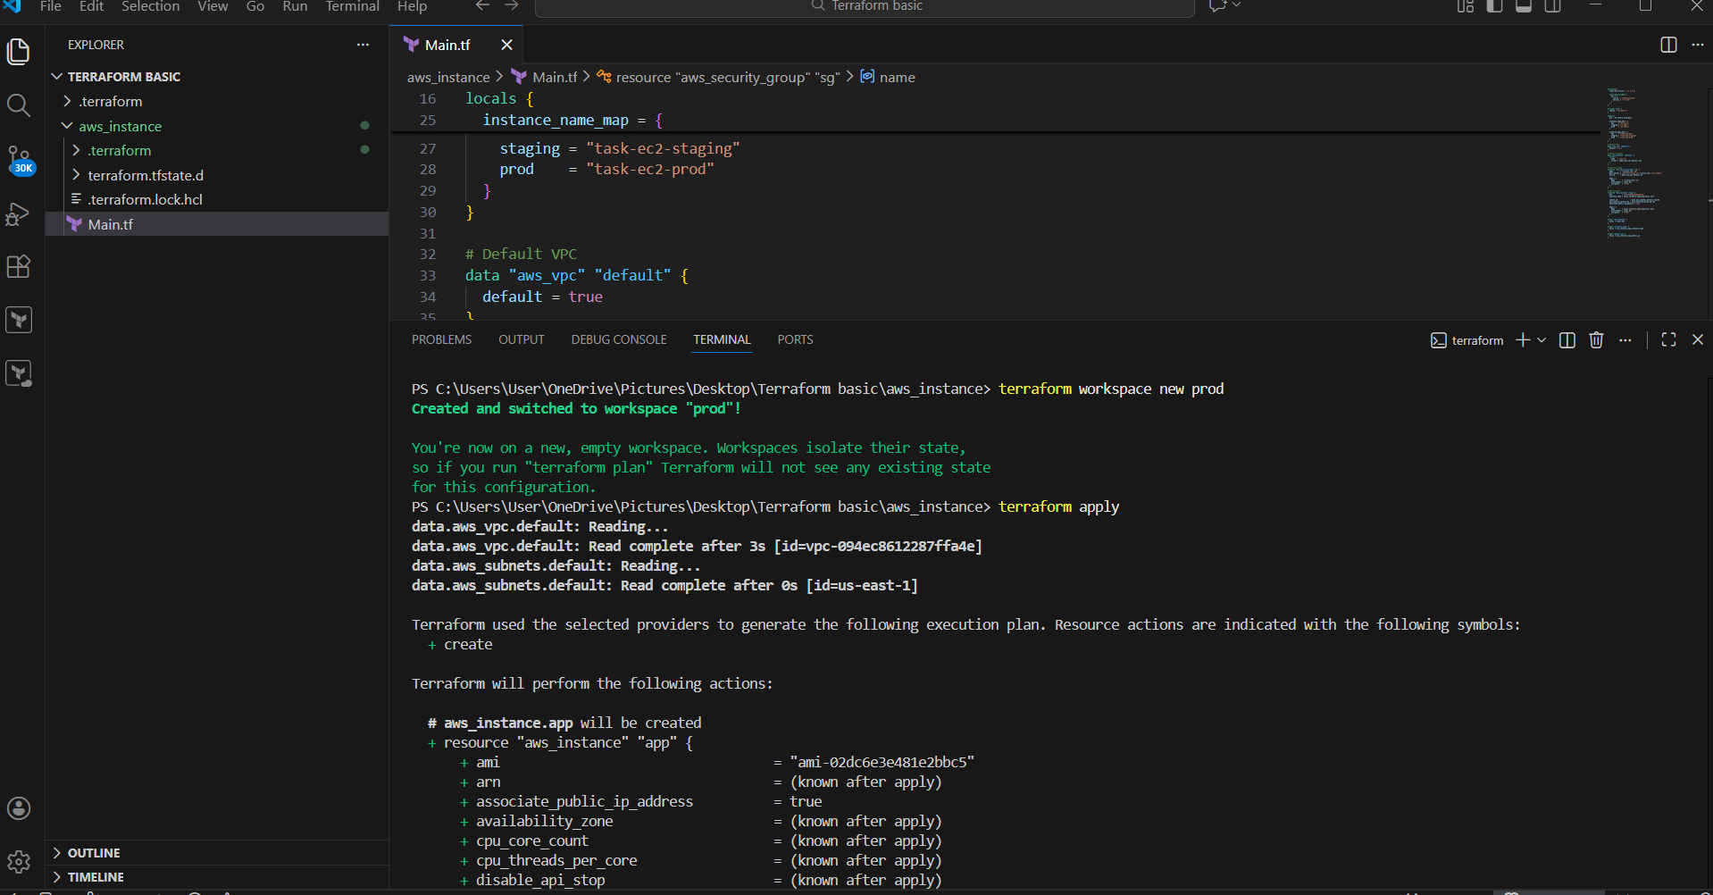
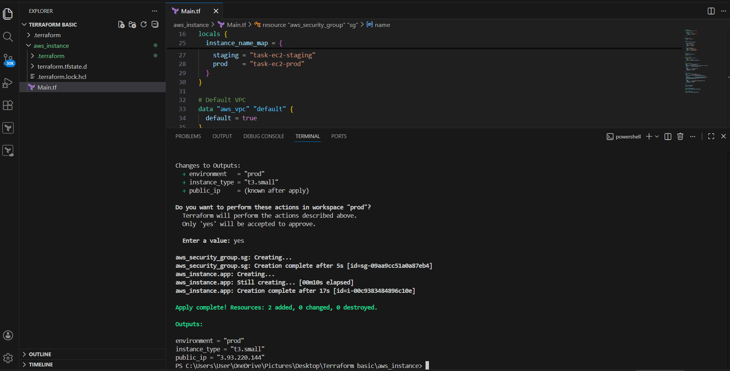
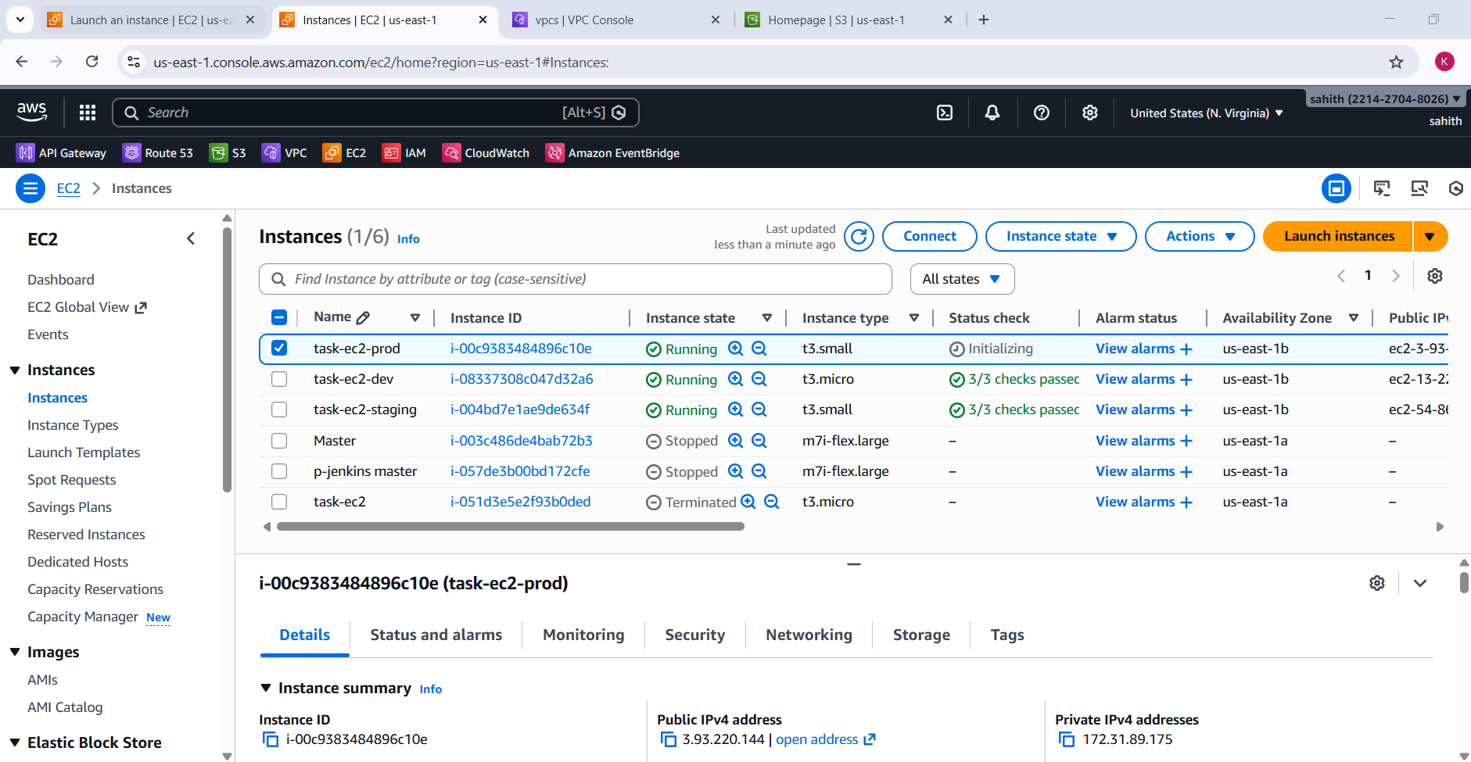

Validation Steps
- Run terraform workspace list to verify active workspace
- Run terraform plan before apply in each workspace
- Check AWS EC2 console for:
  - Instance name
  - Instance type
  - Public IP
- Confirm Terraform outputs match AWS console values
Issues Faced
- Invalid index error
  - Cause: Workspace name (default) not present in local maps
  - Fix: Created explicit workspaces (dev, staging, prod)
- Key not found in map
  - Cause: Workspace mismatch with map keys
  - Fix: Ensured workspace names exactly match local map keys
- State overlap concern
  - Resolved by using Terraform workspaces to isolate state per environment
Conclusion
Successfully implemented multi-environment EC2 provisioning using Terraform workspaces. Each environment now:
- Uses its own isolated state
- Deploys correctly sized EC2 instances
- Applies consistent naming and tagging
- Can be managed independently using Terraform
This setup follows Terraform best practices for environment separation, scalability, and maintainability.

